Walking to Freedom
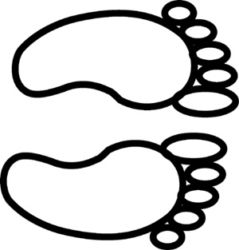
Goal:
The students will be able to recount the story of Israel leaving Egypt.

Materials:
Roll of newsprint
Markers
Pencils

Ideas: Exodus 12
Read the story of Moses leading Israel out of Egypt and towards the Red Sea

Brainstorm:
Who went?
What did they take with them?
What emotions did t hey feel?
Who and what did they leave behind?
What were they looking forward to?
What did God do for them?
What did they do for themselves?

Action:
On a large sheet of newsprint create a banner:
Outline the children’s (adult’s too!) feet in pencil
The children will color the feet and write down the ideas about leaving Egypt that are important to them, on or around their feet.
Outline in large bubble letters the title of the banner, ie: “Leaving Egypt”
The children can use colors and patterns to fill in the lettering, and add pictures

Share and celebrate your accomplishment with family or congregation!
Send cogwebcast.com a photo of your banner☺

